Interagency Work Group on Autism
September 15, 2023
9:00 – 10:30 am
REGISTRATION REQUIRED

 | 9:00 | Welcome, Meeting Norms, Agenda Review  Teresa Kobelt, OCALI  NOTE: Only IWGA members can unmute themselves and turn on cameras.
 | 9:05 | Introductions  - Teresa will “roll call” IWGA members in alphabetical order by last name  - Please wave, say “hello”, “here”, etc. when called on
 | 9:10 | Adult Diagnosis: Lived Experience Panel  Emily Cary, PhD, Nisonger Center, Ohio State University  Alicia Hopkins, IWGA Member  Clare Schloemer, IWGA Member
 | 9:50 | IWGA Member Question & Answer  Public Comments  - First, IWGA members will have a chance to ask question of our panelists/make comments.  - Then, OCALI will call on anyone who registered to make comments. When called on, you can unmute yourself and turn on your camera. You will have 3 minutes for your comments.  NOTE: IWGA members may not have time to respond to comments during meeting (may use chat to share resources, answer questions, etc.).
 | 10:00 | Planning: IWGA Survey & Recommendations  Whole Group Discussion
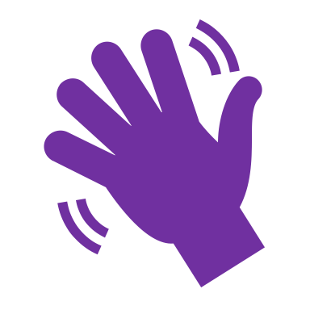 | 10:30 | Wrap Up

NEXT MEETING: October 15, 2023
TOPIC: Joint Meeting of IWGA & Employment First Task Force

