December 15, 2023
9:00 – 10:30 am

 | 9:00 | Welcome, Meeting Norms, Agenda Review  Teresa Kobelt, OCALI  NOTE: Only IWGA members can unmute themselves and turn on cameras.
 | 9:05 | Introductions  - Teresa will “roll call” IWGA members in alphabetical order by last name  - Please wave, say “hello”, “here”, etc. when called on
 | 9:10 | 2024 Goals & Priorities  Teresa Kobelt, OCALI  - Review process and themes from survey  - Review “final” recommended goals & priorities
 | 9:30 | IWGA Member Question & Answer  Public Comments  - First, IWGA members will have a chance to ask questions and make comments.  - Then, OCALI will call guests who registered to make comments. When called on, you can unmute yourself and turn on your camera. You will have 3 minutes for your comments.  NOTE: IWGA members may not have time to respond to comments during meeting (may use chat to share resources, answer questions, etc.).
 | 10:00 | Planning: Moving Forward with Recommendations  Whole Group Discussion
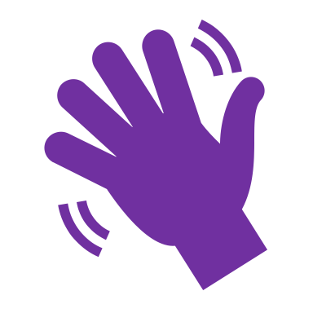 | 10:30 | Wrap Up

NEXT MEETING: January 19, 2024

